snippet/product-list-item.liquid 页面
增加以下代码
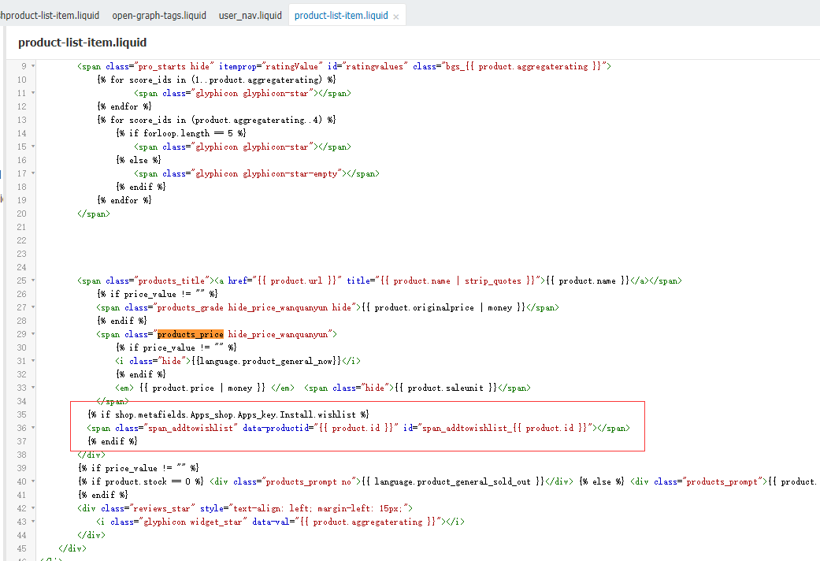
{% if shop.metafields.Apps_shop.Apps_key.Install.wishlist %}
<span class="span_addtowishlist" data-productid="{{ product.id }}" id="span_addtowishlist_{{ product.id }}"></span>
{% endif %}

snippet/open-graph-tags.liquid 页面
增加以下代码
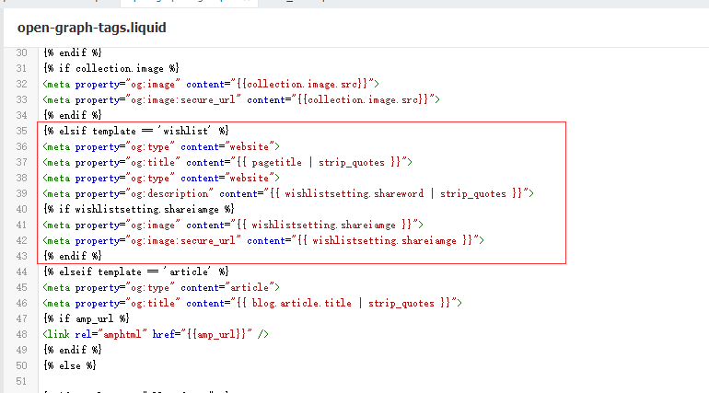
{% elsif template == 'wishlist' %}
<meta property="og:type" content="website">
<meta property="og:title" content="{{ pagetitle | strip_quotes }}">
<meta property="og:type" content="website">
<meta property="og:description" content="{{ wishlistsetting.shareword | strip_quotes }}">
{% if wishlistsetting.shareiamge %}
<meta property="og:image" content="{{ wishlistsetting.shareiamge }}">
<meta property="og:image:secure_url" content="{{ wishlistsetting.shareiamge }}">
{% endif %}

snippet/user_nav.liquid 页面
增加如下代码
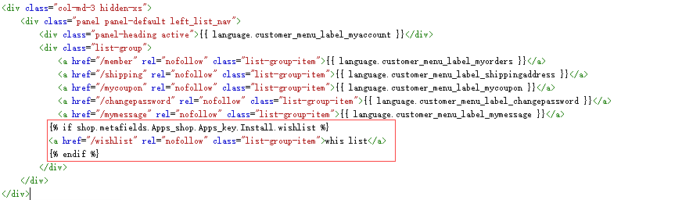
{% if shop.metafields.Apps_shop.Apps_key.Install.wishlist %}
<a href="/wishlist" rel="nofollow" class="list-group-item">whis list</a>
{% endif %}

snippet/wishproduct-list-item.liquid 页面
修改以下代码
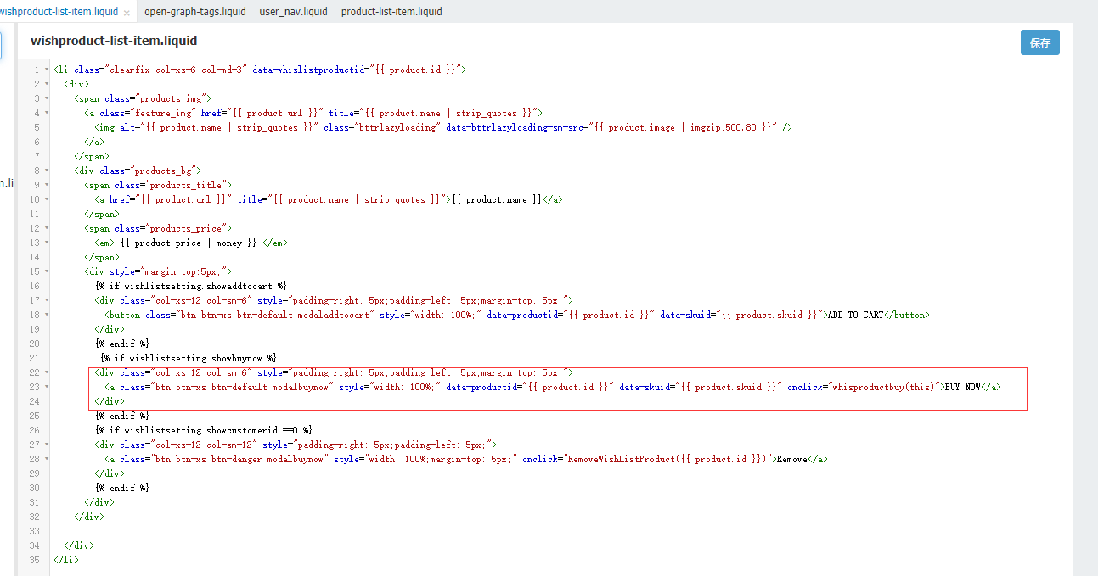
<a class="btn btn-xs btn-default modalbuynow" style="width: 100%;" data-productid="{{ product.id }}" data-skuid="{{ product.skuid }}" onclick="whisproductbuy(this)">BUY NOW</a>

templates/wishlist.liquid页面
增加如下代码
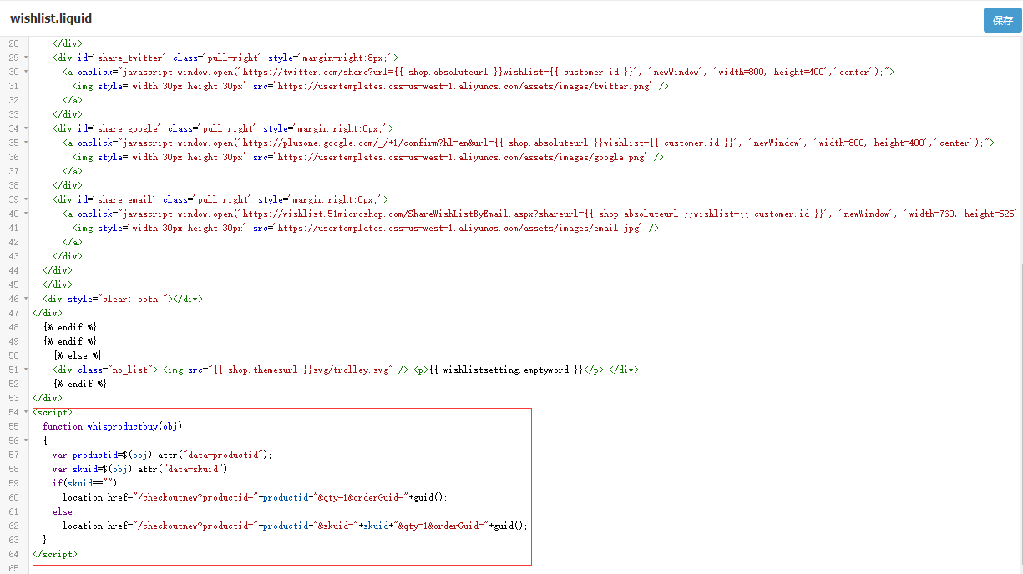
<script>
function whisproductbuy(obj)
{
var productid=$(obj).attr("data-productid");
var skuid=$(obj).attr("data-skuid");
if(skuid=="")
location.href="/checkoutnew?productid="+productid+"&qty=1&orderGuid="+guid();
else
location.href="/checkoutnew?productid="+productid+"&skuid="+skuid+"&qty=1&orderGuid="+guid();
}
</script>

